
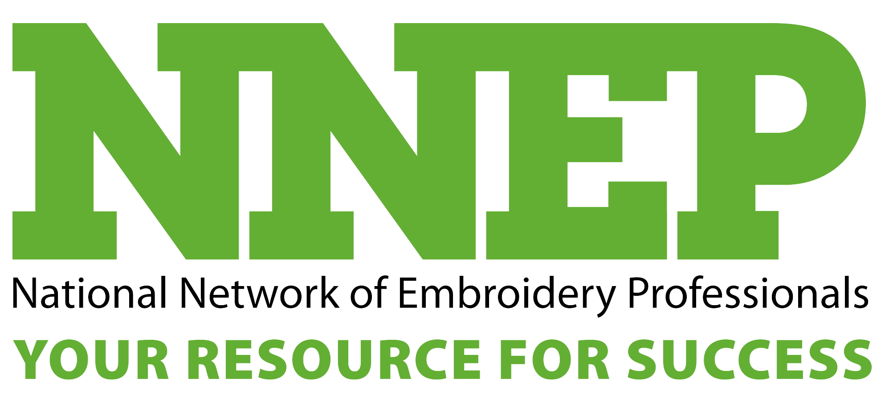
Joe Logo

to the Rescue

If you’re turned off by the prospect of high-pressure sales,
Jennifer Cox will introduce you to someone that can help.

Meet “Joe Logo.”
“Joe Logo is the hardest-working employee that any business owner can have,” says Jennifer Cox of the National Network of Embroidery Professionals in Kent, Ohio. “He never misses a day of work. He never calls in sick. His kids never get sick. He is completely there 24 hours a day, 365 days a year.”
Joe Logo is a character Cox created to help potential customers visualize what embroidery could do for their businesses.
“People don’t realize that they have an incredible resource in their company name and logo,” Cox explains. “If they have not yet purchased embroidery, they’re missing a way to put Joe Logo to work for them.”
Joe was born at 6:30 one morning several years ago as Cox was driving to a weekly business meeting for her professional leads group. The networking organization was designed to help professionals in different fields create sales leads for each other from among their own customers. Explaining to the group why their customers needed to become embroidery customers proved difficult.
“Every week, the group would feature several different businesses for a five to 10-minute presentation,” Cox says. “I came up with Joe Logo.”
To explain the benefits of embroidery, she personified Joe Logo into a valuable employee that everyone in the group could relate to.
“I turned it into an educational sales pitch on how to sell embroidery,” she says.
Her referral group laughed at her characterization of Joe Logo. At the same time, the members finally understood what she was selling, and generated a lot more business for her.
“When you say ‘corporate embroidery,’ they don’t know if their customers would buy that,” Cox says. “But when you talk about Joe Logo being punched in on the time clock with his feet up on the desk twiddling his thumbs ready for you to put him to work, then you’ve got them. They could understand.
“The group members told all their customers that they needed to meet Joe. It left the customers intrigued and created this really great entry for me. ‘I’m the lady that wants to introduce you to Joe.’ It builds a neat presentation.”
Cox thinks that any embroiderer could sell using Joe Logo.
“Embroiderers should be teaching their customers about Joe,” she says. “Whether speaking to a referral group or at a Rotary luncheon, it works in almost any setting. I can do it one-on-one in a sales call. I can talk to a business owner about how I can make his Joe work harder for him, or how I can help create his Joe. I’m selling not just embroidery, but company recognition, brand recognition, customer confirmation and identity stature within the community. I’m offering all of that by way of Joe Logo.”
In her presentations, Cox uses several illustrations of how Joe Logo will help a business.
“I discuss how, as a woman business owner and a homeowner when somebody comes to service my plumbing or cable TV and shows up in an identified van, wearing a logo’d shirt, carrying a badge or I.D., I’m confident because he’s clearly from the company I hired,” she says. “When he walks up wearing embroidery, it gives him the credibility for me to open the door and allow him into my home or business.”
Every company that calls on businesses or homeowners should be using Joe Logo on every wearable surface – bags, hats, jackets, shirts and sweatshirts, she says. “If you have 18 plumbers servicing your community and they all look cleaned up and spiffy, they’re going to generate a community feeling about their services that is much different than the guy that shows up in old ratty jeans and a dirty T-shirt.”
Cox stresses that Joe Logo can also help build camaraderie among employees at company gatherings.
“Nice tone-on-tone embroidery for a golf outing is a classy way to have company brand reinforcement,” she says. “Joe can be as subtle or as brash as they want. If they’re in a bowling contest with other plumbers in the city, they’re going to want Joe to be pretty prominent, so they’ll put him on the back of the shirt.”
“Joe can work for everybody. Everybody knows Joe. Everybody has Joe, but they’re probably not using him very well. He’s their least utilized, most valuable and cheapest employee because he’s never not working.”
Even customers who don’t have an official logo can still have Joe.
“Your font, your colors, your type style, all of that can be your Joe,” Cox says.
Once an embroiderer starts customers thinking about Joe Logo as a tangible member of their staff, it’s easy to generate repeat sales.
“I’ve had customers that two and three years later are still calling me up and saying, ‘Hey, I need to put Joe to work, or Joe’s asleep on the job here and I need to wake him up,” Cox says. “Joe made it easy for them to be thinking about how I could help them use their logo better.”
“They thought it was cool that they were putting Joe to work again. I thought it was really cool that they were spending more money. Once they were putting Joe to work, they didn’t see it as an expense, they saw it as a necessity.”
Joe Logo works because he’s fun.
“People like fun,” Cox says. “People remember fun. It totally changes the sales chemistry, at least it did for me.”
No longer is the sale a high-pressure situation. It’s one that both seller and consumer can laugh about and enjoy, yet embroiderers can be comfortable knowing that they are meeting their customers’ needs.
“Everybody likes to be needed, and psychologically it helps embroiderers perceive their role differently in relation to customers,” Cox says. “That’s critical in the sales process. Believe in your product and the fact that you’re meeting customers’ needs they may not know they have. Through the use of Joe, you can illustrate exactly what those needs are and that you’re the embroiderer to service them.”
Cox encourages embroiderers who want to use Joe Logo in their sales programs to contact her at the NNEP.
“They then need to introduce their customers to Joe or Bob or whatever they want to call him,” she says. “They need to develop their own version of this sales pitch, their own story with which they can be comfortable.”
“Once you introduce your customers to Joe, they won’t be able to run their business without him. And as the embroiderer, you’re where Joe comes from.”

